Synthetic Li Prize Brine for Finalists of Geothermal Lithium Extraction Prize Competition
Ghanashyam Neupane^{1,2} and Robert W. Smith^{2,3}
¹Idaho National Laboratory, Idaho Falls, ID
²Center for Advanced Energy Studies, Idaho Falls, ID
³University of Idaho, Moscow, ID
Email: Ghanashyam.Neupane@inl.gov

Introduction
The Department of Energy (DOE), Geothermal Technologies Office (GTO) launched a multi-phase funding program to advance technologies for extraction of lithium from geothermal brines. This initiative, known as American-Made Geothermal Lithium Extraction Prize (GLEP), had objectives of advancing technology for direct lithium extraction (DLE) from geothermal brines and make it as cost competitive as the conventional lithium extraction methods (e.g., pegmatite mining and salar brine mining).
Phase 1 of this initiative, ‘Concept & Idea’, began on March 31, 2021, and required submission of an application with description of the technologies for the DLE from geothermal brines. After reviewing the Phase 1 applications, GTO selected and funded 15 semifinalists on November 1, 2021. Phase 2 semifinalists presented their progress in late March 2022 during an Innovation and Pitch Meeting and submitted their research results in April 2022. GTO selected five finalists for Phase 3 in July 2022 and provided additional funding to fabricate and test their DLE technologies.
To support these GLEP projects, Idaho National Laboratory (INL) formulated a Synthetic Li Prize Brine (SLPB) and provided it to all Phase 3 finalists to test with their technologies. The SLPB was used as a baseline lithium extraction feed brine for testing the efficacy of direct lithium extraction (DLE) technology developed by finalists. The finalists tested their DLE technologies against the INL-provided brine. Project products (reports and high-light videos) were used GTO to select the winners of this competition.
SLPB Recipe
INL researchers have formulated and tested the shelf-stability of DLE test brines. The synthetic brine recipe was developed by modifying the composition of the Salton Sea geothermal brine (SSGB) reported elsewhere (e.g., Harrar et al., 1979; Maimoni et al., 1982; Gallup, 1998). To formulate the recipe, we conducted geochemical modeling of SSGB as a starting reference composition using The Geochemist’s Workbench® with the Pitzer Thermo_ypm.R2 database to determine the amounts of various salts needed to create a representative and shelf stable SLPB composition. The recipe was formulated in such a way that the SLPB would be free of particulates and/or precipitates at room temperature. Any SSGB constituents with concentrations lower than 40 mmolal (including silica) were not included in the recipe. Sodium, potassium, and calcium concentrations are adjusted such that the SLPB is undersaturated (log Q/K = -0.151) with respect to halite (NaCl) at room temperature by maintaining the K:Ca:Na ratio of the SSGB. After a few iterations of formulation and laboratory testing, the SLPB composition presented in Table 1 (for 500 g of brine) was determined to be adequately shelf stable for at least 69 days and representative of the SSGB.
SLPB Recipe Salts
After discussion with GTO Program Manager and GLEP Industry Advisory Panel (IAP), we determined to deliver a dry mixture of recipe-salts to prepare a total volume of brine ~ 9.442 L in a 10 L carboy. In the first delivery, each finalist was provided with a carboy containing pre-weighed salts. To avoid potential oxidation of redox-sensitive constituents in the salts, air in each carboy was purged with high-purity argon. A datasheet with amount of each salt was provided along with the carboy.
Table 1. Recipe of the Synthetic Li Prize Brine
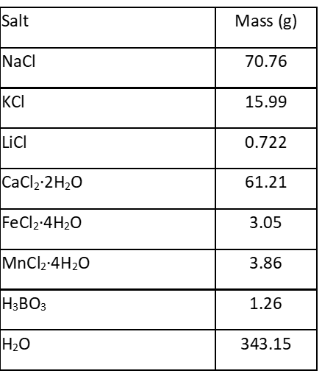
Procedure to prepare SLPB
After receiving the recipe-salts, GLEP finalists prepared the SLPB according to the procedure below.
- Use 8.0 L of nano-pure (>18.2 MΩ.cm) water and sparge it with argon or nitrogen for at least 30 minutes.
- Add 8.0 L of Ar-sparged water to the carboy.
- Stir the brine to completely dissolve the salts.
- Adjust the pH of the brine to ~5.5 with sodium hydroxide and hydrochloric acid solutions (as needed).

Precautions and Lessons Learned
- It is important to avoid air-exposing the brine for a long period. Exposure/contamination of brine with air is likely to induce oxidation of ferrous ions to ferric ions that may cause precipitation of hydrous iron oxides.
- It is very likely that some of the ferrous iron will oxidize, and the color of the brine will turn yellowish. Importantly, if the air-exposure is limited, only a small amount of ferrous iron will oxidize. The brine may require filtration prior to use in DLE (if the small amount of colloidal ferric oxides interferes with the technology). It is important to note here that actual Salton Sea geothermal brines are more prone to create precipitation/scaling issues than the provided SLPB.
- While adding the Ar-sparged water into the carboy, it is recommended to maintain a continuous flow/purge of argon into the carboy. Unless the water is added in an Ar-filled glove box (which may not be necessary but will help avoid air exposure), a tube of low-flow Ar can be inserted into the carboy while the Ar-sparged water is being added. Also, keeping the Ar-flow into the brine (after addition of water) helps agitate the brine for faster dissolution of salts. Alternatively, the competing team can develop an appropriate practice to minimize air exposure while preparing the brine.
- The dissolution of salts in the carboy may take some time. Maintaining an agitative condition in the carboy will facilitate this process.
- After the SLPB is prepared, we recommend storing it in a refrigerator at 4⁰C. We conducted shelf stability test of the brine both at room temperature (22⁰C) and at 4⁰C. With exception of slight difference in visual appearance (small difference in amount of colloidal ferric oxides), we did not observe significant compositional change in brines stored for 69 days (the duration of our evaluation) at room temperature or in refrigerator.
- If any finalists need small amount of brine to work with at a time, we recommend shaking the carboy properly prior to transferring the brine to a smaller container. Again, precautions need to be taken to avoid exposure to air.
References
Gallup, D.L., 1998. Geochemistry of geothermal fluids and well scales, and potential for mineral recovery. Ore geology reviews, 12(4), pp.225-236.
Harrar, J.E., Otto Jr, C.H., Deutscher, S.B., Ryon, R.W. and Tardiff, G.E., 1979. Studies of brine chemistry, precipitation of solids, and scale formation at the Salton Sea geothermal field (No. UCRL-52640). Lawrence Livermore National Lab. (LLNL), Livermore, CA.
Maimoni, A., 1982. Minerals recovery from Salton Sea geothermal brines: A literature review and proposed cementation process. Geothermics, 11(4), pp.239-258.

